Warm Up with 5 min of movement before beginning exercise program.
Do 2-3 sets of 10-15 reps. Rest 1-2 min between sets.

SQUAT/ Stick Ups
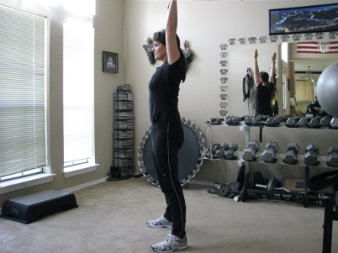 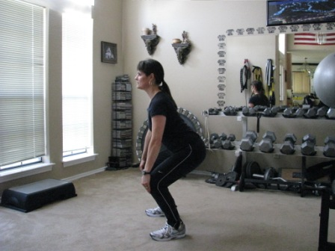Begin with the arms extended over the head, abs engaged and glutes squeezed tight. Squat and lower the arms until the palms cup the knees. Keep the head and shoulders up. Stand back to starting position. Squeeze the gluteus as you stand straight.
Front Kicks
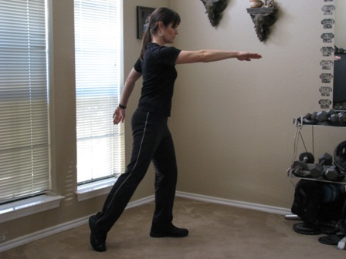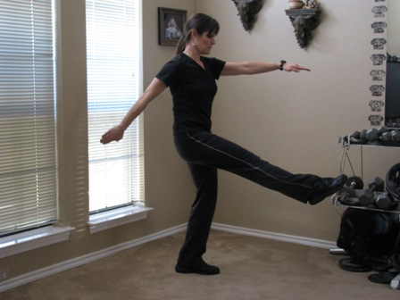Power Front Kicks - Starting Position - Right leg extended behind you, power kick straight leg forward. Maintain tight abs and kegel to support torso.
Notes: Perform exercise on Left and Right sides.
Plank to Pike Stretch
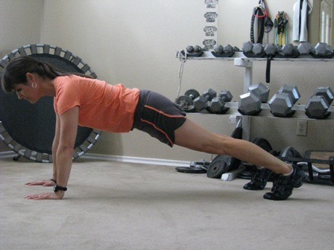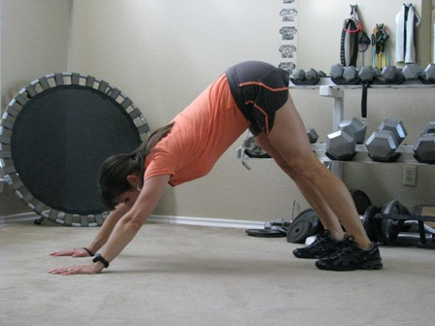Begin in a plank position. Arms extended straight but not locked. Push the shoulders away from the ears. Pull the Ab muscles into back. Keep the hips up at chest height. Feet should width apart. Hold for 2 seconds, now pull the abs in tighter and push the body into a pike position. Press heels to floor, hold 2-5 seconds. Repeat 3 times and work up to 10 times.
BEGINNERS: Starting position: drop the knees to the floor.
Back Rows – Double Time
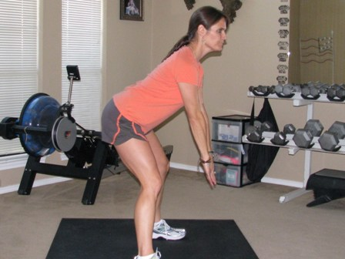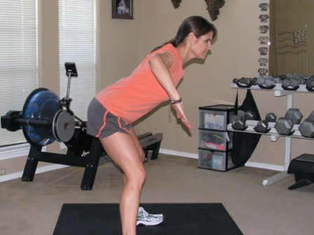Bend forward in a back row position. Back is flat, abs in, glutes engaged to support low back. Arms extended down in front. Pull arms back, bending elbows towards the ceiling. Get comfortable with movement before you perform at a double-time rate. Move through the exercise as quickly as possible maintaining correct form. Repeat for time.
Plank – Mt. climb
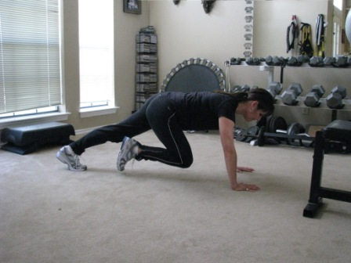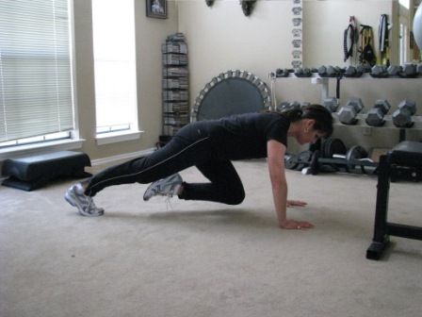Extended plank position - shoulders over wrist, abs tight and pulled in, glutes engaged - draw knee up to chest and quickly alternate with other knee. Quick movement, as knee is drawn forward foot does not touch the ground.
CARDIO/ skater plyo’s
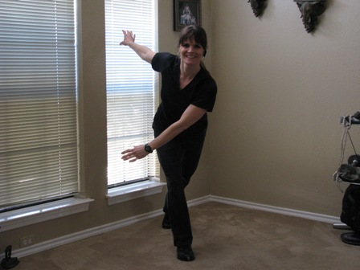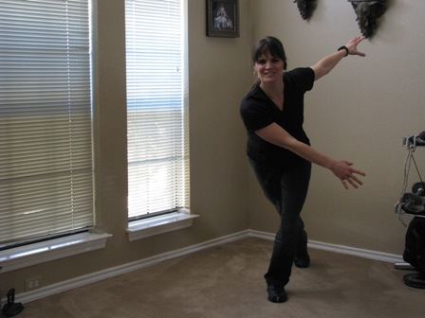Power Minute Exercise - Power Skate - leaping from left to right. Keep chest and head up, abs in. Notes: Power minute - repeat exercise nonstop for 1 min.

Repeat exercises 1 – 2 more times or for the amount of time assigned by your trainer.

